NAME:  DOB: | DISTEMPER | RABIES | WORMED | FLEA  & TICK | WEIGHT | MEDICATION | VET  VISIT | COMMENT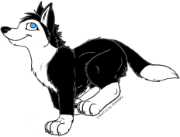
DATE
Coppertop Kennel 207-631-4973  352 Middle Road vrblackwidow@aol.com  Bradford, ME 04410 |  |  |  |  | Mother:  Father:

