TMHSDC Spring 2025 Meeting
April 27, 2025
- Welcome and call to order

- Secretary reading of Spring 2024 minutes. There was a rig race, but no fall meeting held due to the meeting hall at the Dover Fair grounds being double booked.
- Treasurer’s report and approval. $1,014.64 Allen Thomas Fund. $1,499 in checking. Read by Gina.

- Animal welfare report
Charlotte reported that there are two proposed bills. The kennel bill proposes the kennel fee to increase from $42.00 to $50.00. The vaccinator bill allows certified rabies vaccinators where vets are not available.

Correspondence secretary’s report
48 post cards were sent for the summer picnic, 42 for the fall meeting and 45 for the spring meeting.
- OLD BUSINESS-
  - Club website: fixed new website address: mainesleddogclub.org However the site is down today.
  - Club merchandise: new merchandise, sold at trade fair
  - Fundraising
    - Quilt – Tickets were only sold at the trade fair since there were no races this past winter. We will continue to sell tickets for this quilt.
  - Dog Sport Trade Fair
Merchandise was sold, Thomas, Val, Charlotte, Paul, Rhonda, Joel, Shayla and Aspen ran the both. Thomas and Al will take any suggestions to the board to make the trade fair better. Tara mentioned that they could offer rides, collecting a small fee to cover insurance. Laurie mentioned that the course was hard to view as a spectator.

  - Club By-Laws proposed amendment
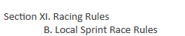
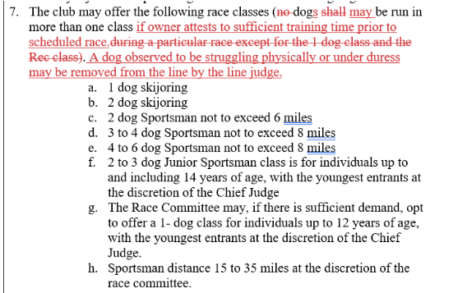
Voted on and passed.
- NEW BUSINESS

    - Fall Rig Race and Meeting – November 9, 2025
    - Bradford Race Dates: January 24, 2026, February 21-22, 2026, March 7, 2026
    - 4H Club attended the fall rig race. Charlotte gave a presentation. Tara gave rides.

  - Leonhard Seppela Award and Allen Thomas Award
The Vice President received two Leonard Seppela (Shayla Stevens and Tara Crossman) and four Allen Thomas (Ed & Val, Thomas Carroll, Tara Crossman and Joel Foster) award nominations. Both awards were voted on by secret ballot. Shayla Stevens won the Leonhard Seppela Award Ed & Val won the Allen Thomas award.

  - Club Officer and Board Member Elections
    - Andrea motioned to vote on the panel as a slate, Val 2nd the motion. Voted on as a slate and unanimously passed.

President – Barth Deuyour
Vice President- Valerie Parent
Treasurer – Gina Deuyour
Secretary and Corresponding Secretary – Charlotte Carroll
Board Members:
Thomas Carroll – 2026
Chris Mitchell-2026
Tara Crossman-2026
Don Banker – 2027
Andrea Hoskins – 2027
Shayla Stevens - 2027

  - Club Equipment – One club timer is not working. The club needs more/new club radios. Charlotte researched pricing for the timers. They are $400-$560.00a piece. Val said we will try to get the broken one repaired and maybe replace one the following year.
  - Club Facebook page – Andrea and Tara would like to see more posts on facebook.
  - Club mentor – Rema says Emma needs to have a mentor to help her accomplish her dream of running the Can Am some day.

- Adjournment, Thank you.
Attendance:
Barth Deuyour, Don Banker Jr., Laurie Schneider, Thomas Carroll, Gina Deuyour, Charlotte Carroll, Ed Parent, Val Parent, Al Paradis, Aspen Foster, Shayla Stevens, Tara Crossman, Jacob Nelson, Andrea Hoskins, Dan Pelletier, Danny Pelletier, Chris Mitchell, Betsy Parker, Rhonda Welcome, Joan Chapman, Gary Chapman, Rema Mitchell, Jeff McRobbie, Shannon Flint, and Leslie Silvia

